Documentation modification of the Kicad project

From KiCad open the .pro

# Load libraries in the project

## Modification of the wiring diagram:

In preferences / Configure symbols path / Global libraries :

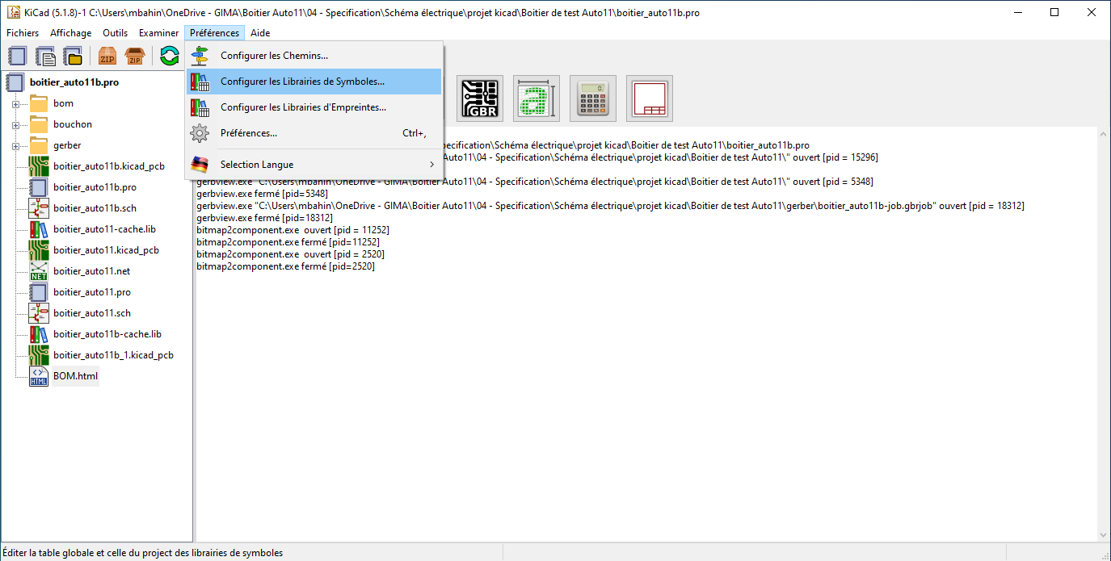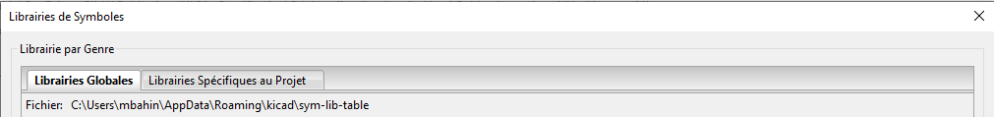

* Click on then select the used libraries



## Modification routing :

In preferences / Configure symbols path / Global libraries :

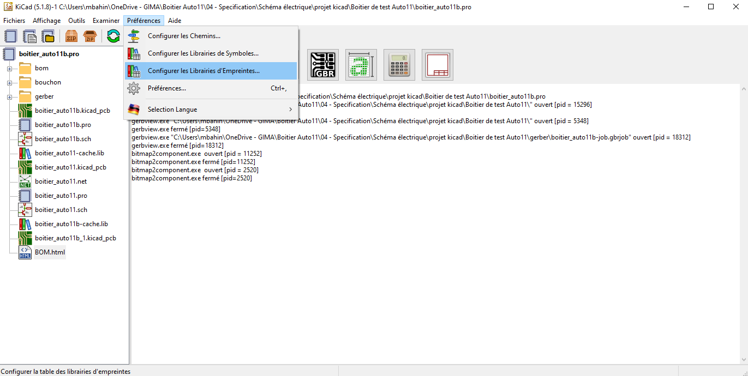

* Click on then select the used footprints



If the libraries are not loaded, some components appear as a box with ? inside (in electronic schematic editing mode).